Loan Risk Financial Analysis
Import and Explore
Data was loaded onto pandas. Upon loading the data, I checked for null and later merged the two data frames on borrower_id.
``` full=pd.merge(loan,borrower, on='borrower_id')```
Segment Analysis
To get a feel of the data, I used matplotlib to see the data distribution (credit scire, debt to income ratio and interest rates) using histograms. The data distribution guided me in creation od segments for later use in data exploration and analysis.
``` full['interest_range']=['Below 4' if x<=4 else '5-8' if x<=8 else '9-12' if x<=12 else 'Above 12' for x in full['interest_rate']]```
``` full['dti_range']=['<25' if x<=25 else '26-50' if x<=50 else '51-75' if x<=75 else '76-100' if x<=100 else '>100' for x in full['dti_ratio']]```
``` full['credit_range']=['500-599' if x<600 else '600-699' if x<700 else '700-799' if x<800 else '800-899' for x in full['credit_score']]```
After creation of the segments, I proceeded to filter the data to focus on defaults only.
```default=full[full['defaulted']==1]```
Thereafter, I explored the default rates by debt-to-income ratio, employment status, interest rates and loan purpose.
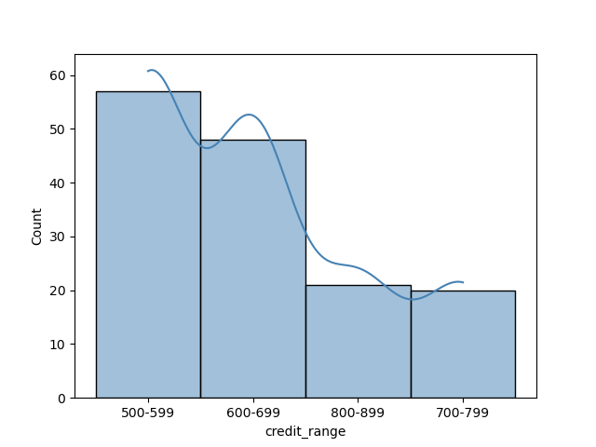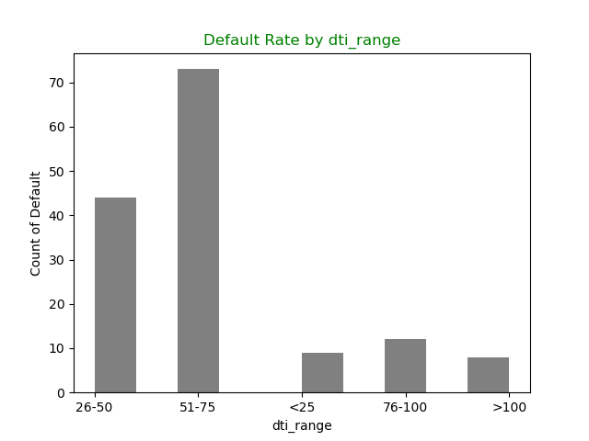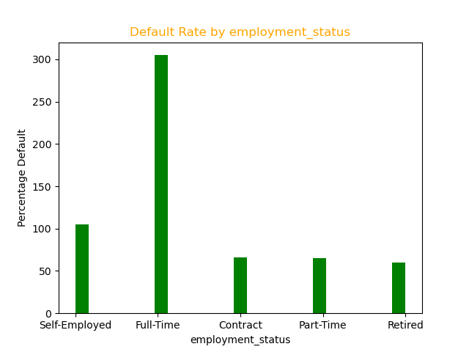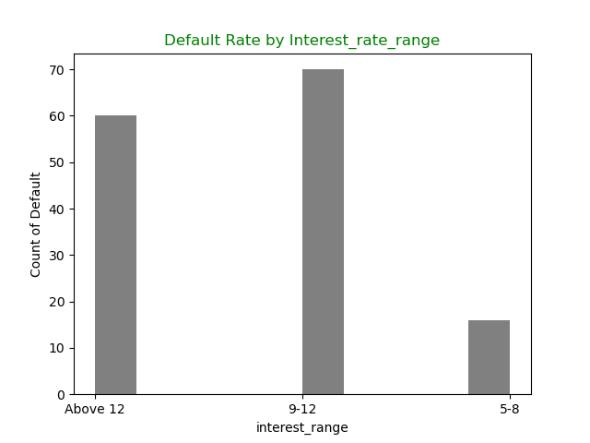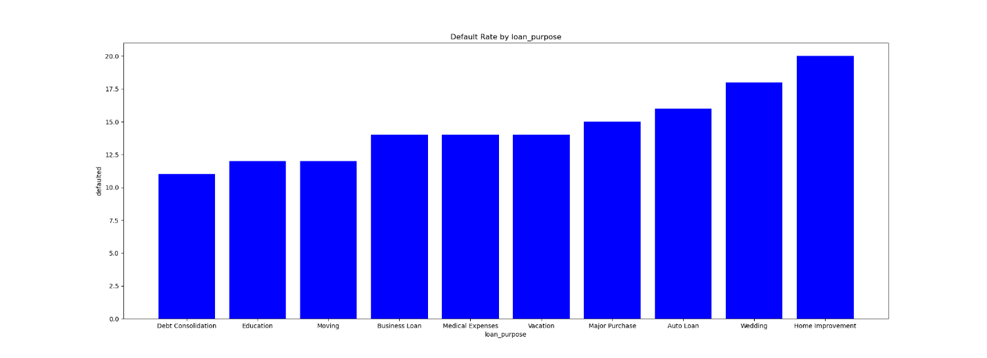

Further analysis to determine the correlation of numeric factors on default are as follows in order of importance

Parameter | Correlation coefficient | Implication | Recommendations
days_delinquent | 0.881093 | There is a positive correlation between days delinquent and default. A one-day increase in delinquency is likely to increase the case of default by 88%. | The maximum days of delinquency of non-default loans is 30 days. Once a loan delinquency goes beyond 30 days, the risk and loan department may need to institute measures to follow up with the loan applicant to remedy the situation.
interest_rate | 0.198930 | There is a positive correlation between days delinquent and default. A one percent increase in interest rates is likely to increase the case of default by 19.8%. | For loans with a variable interest rate, an increase in the interest rates will increase the rate of default. To address this, the institution can shift to a fixed loan rate such that any increase or decrease in rates ensures the institution mitigates the risk of default.
dti_ratio | 0.192454 | The dti_ratio is positively correlated with rates of default. An increase in the ratio is likely to increase the default by 19% | The highest dti_ratio default rate is recorded at dti_ratio above 50. The institution should reject loan approvals for individuals with dti_ratio above 50. Further, the institution can monitor the customers with dti_ratios above 25 that are rising to anticipate the probability of default.
credit_score | -0.286394 | Credit score is negatively correlated with defaults. A decrease in the credit score will increase the likelihood of default by 28% | The highest count of defaults falls below the credit score of 600. The institution should cease approval of all applicants below 600. Further, the institution can encourage the existing customers with credit scores below 600 to improve their score by cutting down expenditure to create room for loan repayment.
Loan_purpose | - | While this parameter has no correlation, wedding and home improvement default rates are above the acceptable 12% default rate | To protect its capital and loan book, the institution should discourage lending for home improvement and weddings. The institution can recover by lending to education, major purchases and medical expenses which has the high interest rate and comparative loan amounts.

Limitation.
The data duration of two years is not sufficient to establish a trend analysis to understand whether default rates are increasing or decreasing over time. Default rates were higher in 2024 compared to 2025. However; without data before 2024, we cannot establish whether the defaults were a event specific or trend driven.
Further, the loans towards home improvement would have generated better insights if we had information about home values vs home improvement loans. We can establish whether the loan exposure is covered by the value of the home and whether the value of the home is increasing over time such that the bank can recover its capital.

